The Unexamined Communist

Socrates is famous for saying (translated from the Greek, of course) that the unexamined life is not worth living. Unfortunately for us (but certainly not Socrates or Plato) there was no social media in Ancient Greece and, equally unfortunately, that pearl of wisdom seems to have fallen by the wayside in our digital age. Case in point: small minds trolling about in today's hyper-charged hypersensitive Twitter-verse using the apparatus of modern life to condemn capitalism. Using goods and services that are the result of countless free-market decisions, these clowns sit comfortably in a lofty, little perch from which they dish out small, vapid critiques of a system that produced the very infrastructure they use to condemn it. The irony here is beyond anything that could ever have been produced by the thinkers of the Academy and the Lyceum combined.

To fully drink in the incongruity, consider for a moment all the various economic spheres that have to converge to allow a disgruntled, twenty-something-year-old the ability to level criticism against the luxury in which he exists. To be concrete, let’s examine some of infrastructure needed to put up a simple video on YouTube. This analysis is, in some sense, a modern retelling of that venerable article, I Pencil, by Leonard E. Read written in 1958, which shows that literally no one knows all the steps in making something as simple as a Number 2 pencil.

Our scenario will start with our disgruntled content maker, no doubt living in his parents’ basement, with a heart filled with bitterness and a skull mostly devoid of marketable skills but rife with fears (how will I pay my student debt?) and with regrets (why did I ever get that degree in medieval Grail romances?). Having just finished eating dinner (a dinner he did not grow or hunt or even prepare), he washes his hands, uses the toilet, trundles to his air-conditioned cubby, flips on the lights, and logs into his laptop, at which point he is ready to pepper the internet with his injective against capitalism.

Those simple actions just describe touch upon some of the most important of the economic sectors. The folks at Simplicable, in an article entitled 23 Sectors of the Economy, define what an economic sector is and list their taxonomy. Depending on one’s purpose, other kinds of divisions are possible and common (e.g. academic economists only see four sectors). These details don’t matter as much as the fact the activity that takes place, regardless of dividing lines, are entirely or mostly capitalistic, meaning that private individuals own the means and make the decisions for what is produced, how much is produced, and who gets to consume.

Start with the house itself. Building a house is far more complex than building a number 2 pencil since a house is a set of subsystems or units, each at least as complex as a number 2 pencil, that that all need to work together. First there's the foundation and the actual structure that holds everything up; an incredible mix of concrete, wood, and metal; each serving its own purpose; each bearing its own load. The wood comes from trees in a forest and must move through an intricate webwork of supply chains and activities just to result in a 2x4.

Next, for a house to be considered even remotely habitable in this modern age, it will need electricity. Raw metals, typically copper, will have to be mined and then transported to a plant where it will be transformed into various gauges of wire and various components required for residential use. Circuits will run between the main and various rooms designed to use (one-phase here and two-phase there) and circuit breakers will have to be installed according to codes (a 20-amp breaker here a 30-amp breaker there) that allow us to safely use something that could easily kill us.

Then there's the common need for a heating, ventilation, and air conditioning (HVAC) system. There must be a way getting fresh air into the home, keeping the place heated when it gets cold, and it's highly unlikely that a college-trained intellectual would ever consent to live in a house without air conditioning so we'll check that box too. An HVAC system, all on its own, is a very complicated interplay between multiple economic sectors. Miners find the raw materials that eventually find their way into the sheet metal that is bent to particular specifications to produce ducts, and furnace manifolds, and so on. Certain houses will need specialized lines for handling natural gas safely along with ingenious pilot lights or other auto-ignition systems that enable the system to turn off and on without human intervention. And we can be sure that our YouTuber will want to avail himself of the sophisticated furnace filters that use an internet-of-things approach to automatically notify you when the dirt level demands their replacement (perhaps they will even sponsor his channel). Can’t waste time wondering whether the filters should be replaced when you should be out saving the world from the evils of the profit motive.

The simple action of eating dinner and then washing up afterwards involves multiple economic sectors as well. Agriculture efforts are needed to grow the organic quinoa and free-range chicken he insists on enjoying. A transportation network of trucks, boats, and planes is needed to take harvested goods to the processing plants and then to the supermarkets for his parents to buy.

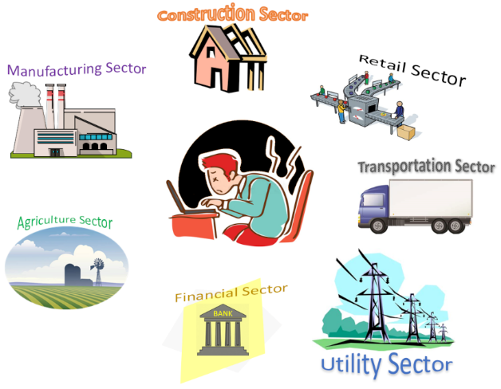

Then there is the financial sector that enables his parents to put gasoline in their hybrid and drive to the local market where they pay with cash-back or points-reward credit card. This infrastructure, which allows them to enter a store, pick 32 specific items, checkout and drive home without ever handing over any cash goes completely unnoticed. This very same infrastructure also enables the mortgage on the house, the insurance premiums and payouts, and numerous other transactions, large and small that keep the household running smoothly.

Going hand-in-hand with the financial sector is retail. The ability to have innovative people realize an idea into a product that betters our lives would not be possible without the financial underpinnings of investments. These investments permit businesses to higher labor, design new goods and services, and purchase the assembly plants and distribution centers that turn these designs into things we consume. Companies, like Amazon and Apple, use this retail model to continually feed our man with the electronic products he craves; the ones that will allow him to make that one viral video that will change the world.

But no economic sector is, perhaps, as important to our modern-day hero than the utility sector. Ignore for the moment (as does he) the fact that this sector pumps the fresh water that he and his family need to drink and bath straight into the home (no trips to a well for someone whose mission is to save the world from private enterprise). Rather, focus on the those ever-so-vital electrical interactions that make modern life possible: the power that runs the air conditioning and the washing machine and the dish washer and the refrigerator; as well as the signals skipping to and fro bringing connectivity to the social media platforms that will carry his liberating manifesto to all the oppressed so that they may throw off the shackles of their high standard of living.

This narrative, of course, only scratches the surface. There are countless other ‘capitalist-enabled’ interactions that this poor deluded soul engages in. Retail stores, like Home Depot and Lowe's, provide the basic products like carpeting and the drywall that make his house comfortable. Vendors, like Hobby Lobby or Home Sense, provide the decorations and little knick-knacks that make a house a home. There are also the countless innovations, from fiber optics to CCD cameras to compact microphones, that connect to his laptop for the express purpose of making a video in which he can decry, with a huge helping of hubris, the evils of the system that enables his incredible style of living.

In the end, instead of having a hero of the people we have a person totally devoid of self-reflection or even an awareness of the bigger community into which he belongs who rails on social media about the inequities of the system and who speaks affectionately for communism. And all because it is easier to look at the capitalist system and find within it the conspiracy that explains his failures than it is for him to own them. Maybe he should have gone to a vocational school where he could have learned to weld. He wouldn’t be as plugged in to the revolution but at least he wouldn’t be living in his parents’ basement.

